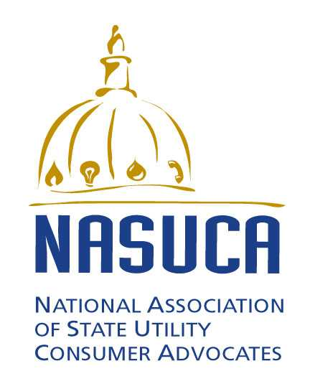
June 18, 2015
Contact:
Regina Costa, Chair, Telecommunication Committee, NASUCA
Telecommunications Policy Director
TURN
(415) 786-8831
rcosta@turn.org

FOR IMMEDIATE RELEASE
STATEMENT OF THE NATIONAL ASSOCIATION OF STATE UTILITY CONSUMER ADVOCATES IN RESPONSE TO THE FCC’S BROADBAND LIFELINE NOTICE OF PROPOSED RULEMAKING

The National Association of State Utility Consumer Advocates (“NASUCA”) supports the Federal Communications Commission's effort to expand Lifeline service to include broadband Internet access ("broadband"). NASUCA has been a staunch supporter of the national effort to ensure that all Americans can receive affordable access to essential communications services, including expanding the Lifeline program to include broadband.
In the 21st Century, broadband is, like voice telephone, an essential service. Telephone service remains essential for communication and public safety, while broadband access is necessary for full participation in society. For example, households now must use broadband to research employment opportunities, submit job applications, communicate with health care providers, complete homework assignments and obtain school information, apply for government programs and participate in e-commerce, a vital part of our national and regional economies.
NASUCA applauds the FCC on today's Notice. We look forward to working with the FCC to design a sustainable broadband Lifeline program that delivers ubiquitous, affordable access to this essential service at a reasonable cost.

ABOUT NASUCA

NASUCA is a voluntary association of advocate offices in more than 40 states and the District of Columbia, incorporated in Florida as a non-profit corporation. NASUCA’s members are designated by laws of their respective jurisdictions to represent the interests of utility consumers before state and federal regulators and in the courts. Members operate independently from state utility commissions as advocates for utility ratepayers. Some NASUCA member offices are separately established advocate organizations while others are divisions of larger state agencies (e.g., the state Attorney General’s office). NASUCA’s associate and affiliate members also serve utility consumers but are not created by state law or do not have statewide authority. Some NASUCA member offices advocate in states whose respective state commissions do not have jurisdiction over certain telecommunications issues.

