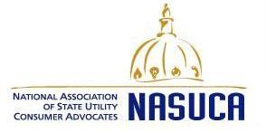
FOR IMMEDIATE RELEASE March 5, 2012 Contact: Charles Acquard
301-589-6313
charlie@nasuca.org

NASUCA Calls on FERC to Modify Transmission Policies

Washington, D.C. -- The National Association of State Utility Consumer Advocates (NASUCA) today called on the Federal Energy Regulatory Commission (FERC) to modify its transmission policies to "better protect consumers and advance policy goals."

NASUCA, joining with dozens of consumer, environmental, utility, Attorneys General, and state regulatory representatives, filed a letter with the FERC saying that the "current incentive structure places unwarranted burdens on consumers, and diverts ratepayer capital away from other important electric infrastructure investments. " The letter is attached.

The letter encourages FERC to:

- grant risk-reducing incentives first and award above-cost incentives rarely;
- not provide incentives to projects that transmission providers are already obligated to build;
- not incent expensive solutions when lower-cost alternatives are available;
- not base eligibility for above-cost rewards on project scale;
- not apply ROE adders to cost overruns;
- not apply ROE adders to abandoned plant amounts;
- identify types of projects that are presumptively ineligible for incentives; and
- make the price of incentives transparent.

NASUCA is a non-profit, national organization of more than 40 state offices designated to represent consumers in state and federal utility proceedings. NASUCA regularly participates in proceedings before the Federal Energy Regulatory Commission, the Federal Communications Commission, and other federal regulatory agencies.

-30-

