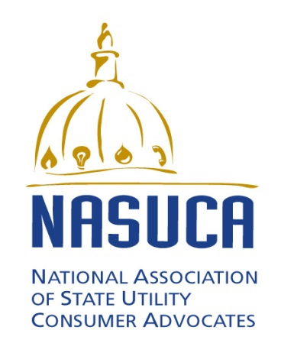

FOR IMMEDIATE RELEASE: November 5, 2015 (Silver Spring, MD)

Contact: Bob Nelson, President, NASUCA, (406) 444-9699, robnelson@mt.gov
or David Springe, david.springe@nasuca.org
DAVID SPRINGE NAMED EXECUTIVE DIRECTOR OF
NATIONAL ASSOCIATION OF STATE UTILITY CONSUMER ADVOCATES

Silver Spring, MD – Bob Nelson, President of the National Association of State Utility Consumer Advocates (NASUCA), announced today that the NASUCA Executive Committee has named David Springe NASUCA’s new Executive Director. Mr. Springe will start his position with NASUCA on December 5, 2015.
“David is ideally suited for this position,” said Nelson. “He has spent thirteen years as a state-level consumer advocate, served as NASUCA’s President from 2007-2009, and has represented utility customer perspectives at many industry conferences and on numerous industry advisory boards. He is a well-known and widely respected advocate for utility customers, and will be a strong Executive Director for NASUCA.”
“I’m honored by this appointment,” said Springe. “I truly believe in NASUCA as an organization and in the important role that NASUCA member offices play in ensuring that utility customer voices are being heard whenever energy, telecommunication and water policy is debated. NASUCA plays an extremely important role in safeguarding customer access to reliable and affordable utility service. I look forward to expanding the opportunities for NASUCA members to engage the industry, state and federal government, and other stakeholders, and bring focus to customer concerns during these challenging times.”
David Springe has served as Consumer Counsel of the Kansas Citizens’ Utility Ratepayer Board (CURB), a NASUCA member office, since 2002. Mr. Springe has represented customer interests on numerous boards, including serving as the Vice-Chair of the EPRI Energy Efficiency and Grid Modernization Public Advisory Board, and serving on the Edison Foundation’s Institute for Electric Efficiency Advisory Board, the University of Missouri Financial Research Institute Advisory Board, the New Mexico State University Center for Public Utilities Advisory Board, and on the Energy Board of the Keystone Center. Mr. Springe received his law degree and masters degree in Economics from the University of Kansas.
NASUCA is a voluntary association of 44 consumer advocate offices in 41 states and the District of Columbia. NASUCA’s members are designated by the laws of their respective jurisdictions to represent the interests of utility consumers before state and federal regulators and in the courts. See NASUCA.org for more information.

