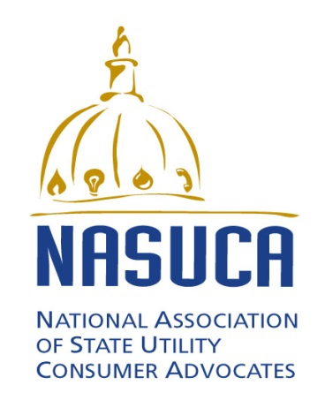

FOR IMMEDIATE RELASE
May 14, 2015
For more information contact:
Charles Acquard, NASUCA, 301-589-6313
Liz Stanton, Synapse Energy Economics, 617-661-3248
NASUCA Releases Tool Kit for Clean Power Plan Compliance
Washington, D.C. -- The National Association of State Utility Consumer Advocates (NASUCA) today released a report that will help state consumer advocates work with states to address the U.S. Environmental Protection Agency’s (EPA’s) Clean Power Plan.
The report was prepared for NASUCA by Synapse Energy Economics pursuant to a grant from the Energy Foundation. The report is posted at www.nasuca.org and is attached.
The report, titled “Best Practices for Clean Power Plan Compliance”, will help consumer advocates effectively participate in the decision-making processes for states to comply with whatever final regulations are promulgated by the EPA. This participation can help assure that costs to consumers are not incurred unnecessarily and that consumers receive the best possible value for money spent.
Recognizing that NASUCA members have a wide range of reactions to the EPA’s Clean Power Plan, the intent of the report is not for NASUCA to take positions as to the plan’s substance or to comprehend every conceivable issue consumers in a particular state might face. Nor does the report in any way represent the distilled opinions of NASUCA’s membership. Just as individual states will vary in their responses to the plan, the intent of this report is to be a common resource to help all of NASUCA’s members prepare to address Clean Power Plan issues whatever their individual state’s positions.
NASUCA is an association of consumer advocates offices in 40 states and the District of Columbia. NASUCA’s members are designated by the laws of their respective jurisdictions to represent the interests of utility consumers before state and federal regulators and in the courts.
-30-

