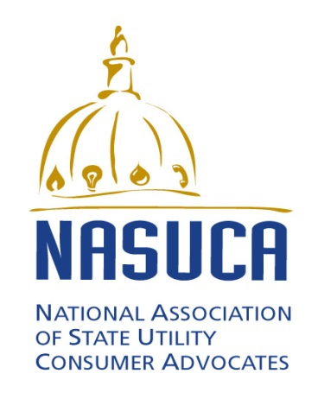

FOR IMMEDIATE RELAS
July 31, 2015
For more information, contact:
Bill Levis, NASUCA, 303-949-1129
Liz Stanton, Synapse Energy Economics, 617-661-3248
NASUCA Releases Report Modeling Single- versus Multi-State Approaches to Clean Power Plan Compliance
Washington, D.C. -- The National Association of State Utility Consumer Advocates (NASUCA) today released a report to help state consumer advocates prioritize how they should work to address the U.S. Environmental Protection Agency’s (EPA’s) Clean Power Plan.
The report, “Multi-State Compliance with the Clean Power Plan in CP3T”, applies high-level computer modeling to different combinations of states to look at whether consumers might save money from multi-state compliance approaches or whether states are better off going it alone. The report concludes that states may be able to achieve some savings by acting together, but emphasizes the importance of pursuing those resources that are the lowest cost for their particular states whether they act singly or in combination.
The report utilizes the Clean Power Plan Planning Tool (“CP3T”), a free open source Excel-based computer modeling tool Synapse Energy Economics developed, to compare single- and multi-state scenarios of states across the nation. CP3T includes individual generator level detail and can quickly be customized. In this report, CP3T does not predict exact outcomes for particular states. Instead, it provides a range of overall outcomes using different scenarios.
Because NASUCA members have various positions on the EPA’s Clean Power Plan, the report does not take positions on the substantive merits of the CPP. Instead, the report is an informational resource to help NASUCA’s members address Clean Power Plan issues as cost-effectively as possible.
Synapse Energy Economics prepared the report, posted at www.nasuca.org, for NASUCA pursuant to a grant from the Energy Foundation. NASUCA is an association of 44 consumer advocates offices in 40 states and the District of Columbia. NASUCA’s members represent the interests of utility consumers before state and federal regulators and in the courts.

