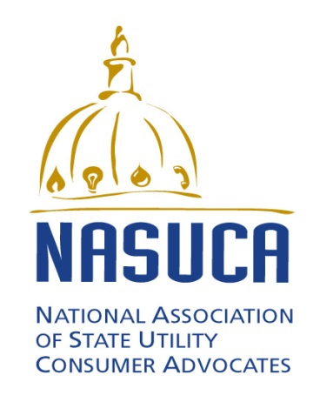

Contact:
Bob Nelson
President, NASUCA
(406) 444-9699
robnelson@mt.gov

FOR IMMEDIATE RELEASE

FORMER COLORADO CONSUMER ADVOCATE BILL LEVIS NAMED
INTERIM EXECUTIVE DIRECTOR OF
NATIONAL ASSOCIATION OF STATE UTILITY CONSUMER ADVOCATES

Silver Spring, MD – Bill Levis has been appointed interim executive director of the National Association of State Utility Consumer Advocates, Bob Nelson, NASUCA president announced on July 27, 2015. Levis succeeds Charlie Acquard who has stepped down after 19 years with the organization. Nicole Haslup will continue as deputy director.
Levis was Colorado Consumer Counsel for five years from 2009 through 2013. During that time, he represented residential, small business and agricultural consumers in energy and telecommunications proceedings before the state Public Utilities Commission. He also was a member of NASUCA’s executive committee and was the consumer advocate on the eight member Federal-State Joint Board on Universal Service.
Since retiring as Consumer Counsel, Levis has been a senior fellow with Silicon Flatirons at the University of Colorado law school and a volunteer lobbyist for AARP. He also is president of the board of directors of Rocky Mountain Health Care Services in Colorado Springs, CO as well as past president and a board member of the Brain Injury Alliance of Colorado.
Prior to becoming Consumer Counsel, Levis was director of public policy for MCI where for nearly 20 years he represented the company before public utilities commissions and legislatures in 20 states. He also served as an assistant attorney general with the Colorado Department of Law and was the Rocky Mountain regional attorney for the U. S. Commission on Civil Rights.

